HOTEL MANAGEMENT SYSTEM

SECOND REVIEW REPORT

Submitted by

**Group Member 1: ROHIN GOYAL (19BIT0140)**

**Group Member 2: SUBHAM SUBHASISH PANDA (19BIT0093)**

**Group Member 3: AARUSH AGARWAL (19BIT0098)**

**Group Member 4: ADITYA (19BIT0139)**

Prepared For

**DATABASE SYSTEMS (ITE1003) – PROJECT COMPONENT**

Submitted To

**Dharmendra Singh Rajput**

**Associate Professor (Sr)**

**School of Information Technology (SITE)**



Contents

1. Introduction 3

2. Key Contacts and Stakeholders 3

**3. Project Software Requirements……………………………………………………………..3**

4. ER Diagram 3

5. Schema Diagram 6

6. Tables and Constraints 6

**7. Records And Queries..………………………………………………………………………10**

# Introduction

Hotels are the major generators of tourist. Hotel Management involves a combination of various skills like management, marketing, human resource development, financial development, dexterity, etc.

Activities in the area of Hotel Management involves ensuring that all the operations like food and drinks, accommodation including the maintenance of finance and personal details of all the employee are well served.

The reservations, registrations, accounts, services, payment mode, extra activities are to be handled and maintained carefully and in an effective way to satisfy the guest as well as to check there is no leakage of profit to the hotel. The tool required for that is a strong database.

# Key Contacts and Stakeholders

|  |  |  |
| --- | --- | --- |
| **Name** | **Registration Number** | **Phone Number** |
| **Rohin Goyal** | **19BIT0140** | **9636293457** |
| **Subham Subhasish Panda** | **19BIT0093** | **9777615319** |
| **Aditya** | **19BIT0139** | **7979910425** |
| **Aarush Agarwal** | **19BIT0098** | **9150554960** |

# Project Software Requirements

* Windows 10
* Oracle Live SQL

# ER Diagram

Here, Bold Line (PINK) represents Total Participation whereas Normal Line (BLUE) represents Partial Participation. Here, RED colour denotes Primary Key, BLUE colour signifies Partial Key and YELLOW colour represents Attributes.

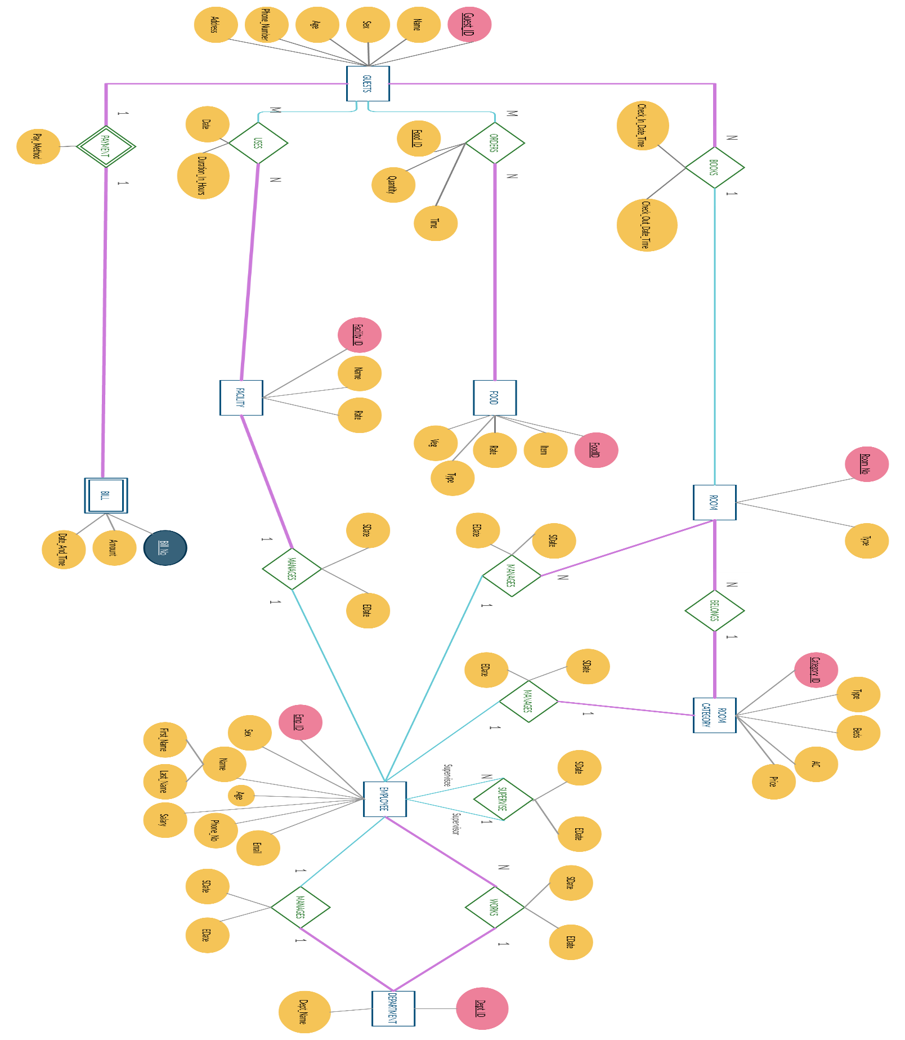

# Schema Diagram

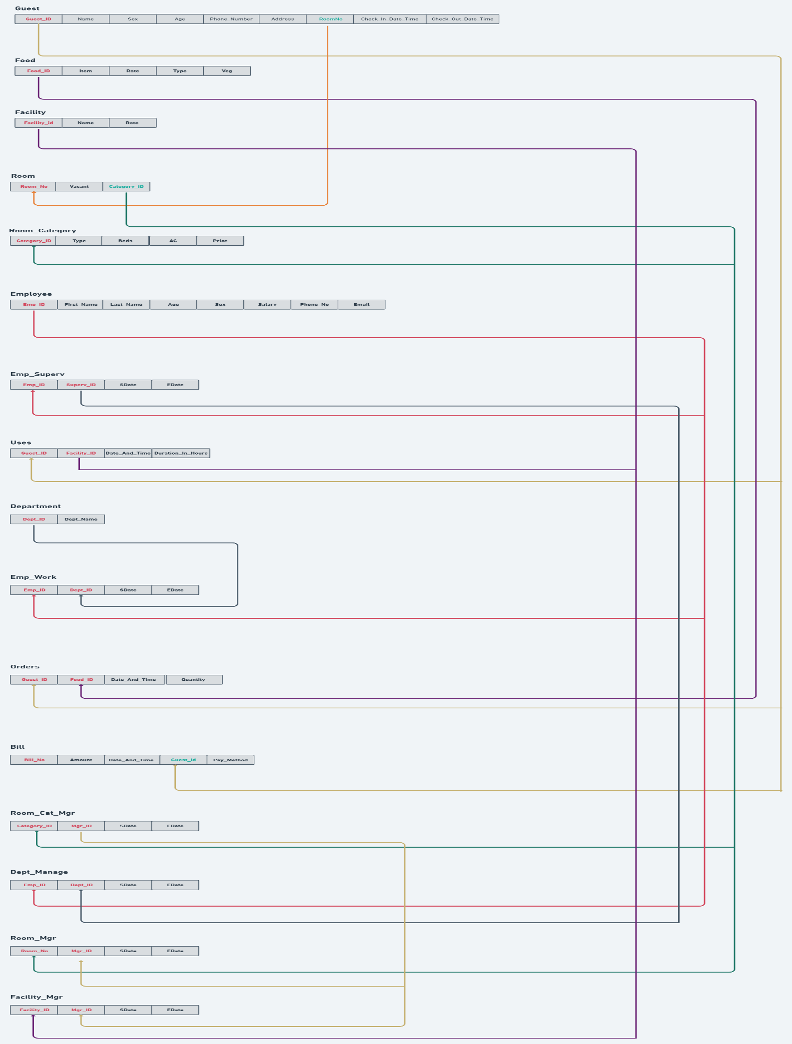

# Tables and Constraints

Guest:

|  |  |  |
| --- | --- | --- |
| **ATTRIBUTES** | **DATA TYPES** | **CONSTRAINTS** |
| **Guest_ID** | VARCHAR2 | PRIMARY KEY |
| **Name** | VARCHAR2 | NOT NULL |
| **Sex** | CHAR | NOT NULL |
| **Age** | NUMBER | CHECK (Age>0) |
| **Phone_Number** | NUMBER | NOT NULL |
| **Address** | VARCHAR2 |  |
| **Room_No** | NUMBER | FOREIGN KEY REFERENCES Room(Room_No) |
| **Check_In_Date_Time** | VARCHAR 2 | TIMESTAMP |
| **Check_Out_Date_Time** | VARCHAR2 | TIMESTAMP |

Food:

|  |  |  |
| --- | --- | --- |
| **ATTRIBUTES** | **DATA TYPES** | **CONSTRAINTS** |
| **Food_ID** | VARCHAR2 | PRIMARY KEY |
| **Item** | VARCHAR2 | NOT NULL |
| **Rate** | NUMBER | NOT NULL |
| **Type** | VARCHAR2 |  |
| **Veg** | CHAR | NOT NULL |

Facility:

|  |  |  |
| --- | --- | --- |
| **ATTRIBUTES** | **DATA TYPES** | **CONSTRAINTS** |
| **Facility_ID** | VARCHAR2 | PRIMARY KEY |
| **Name** | VARCHAR2 | NOT NULL |
| **Rate** | NUMBER | NOT NULL |

Room:

|  |  |  |
| --- | --- | --- |
| **ATTRIBUTES** | **DATA TYPES** | **CONSTRAINTS** |
| **Room_No** | NUMBER | PRIMARY KEY |
| **Vacant** | CHAR | NOT NULL |
| **Category_ID** | VARCHAR2 | NOT NULL, FOREIGN KEY  REFERENCES Room_Category(Category_ID) |

Room_Category:

|  |  |  |
| --- | --- | --- |
| **ATTRIBUTES** | **DATA TYPES** | **CONSTRAINTS** |
| **Category_ID** | VARCHAR2 | PRIMARY KEY |
| **Type** | CHAR |  |
| **Beds** | VARCHAR2 |  |
| **AC** | CHAR | NOT NULL |
| **Price** | NUMBER | NOT NULL |

Employee:

|  |  |  |
| --- | --- | --- |
| **ATTRIBUTES** | **DATA TYPES** | **CONSTRAINTS** |
| **Emp_ID** | VARCHAR2 | PRIMARY KEY |
| **First_Name** | VARCHAR2 | NOT NULL |
| **Last_Name** | VARCHAR2 |  |
| **Age** | NUMBER | NOT NULL |
| **Sex** | CHAR | NOT NULL |
| **Salary** | NUMBER | NOT NULL |
| **Phone_No** | NUMBER |  |
| **Email** | VARCHAR 2 | UNIQUE |

Emp_Superv:

|  |  |  |
| --- | --- | --- |
| **ATTRIBUTES** | **DATA TYPES** | **CONSTRAINTS** |
| **Emp_ID** | VARCHAR2 | PRIMARY KEY |
| **Superv_ID** | VARCHAR2 | PRIMARY KEY |
| **SDate** | DATE | NOT NULL |
| **EDate** | DATE |  |

Uses:

|  |  |  |
| --- | --- | --- |
| **ATTRIBUTES** | **DATA TYPES** | **CONSTRAINTS** |
| **Guest_ID** | VARCHAR2 | PRIMARY KEY |
| **Facility_ID** | VARCHAR2 | PRIMARY KEY |
| **Date_And_Time** | TIMESTAMP | NOT NULL |
| **Duration_In_Hours** | NUMBER | NOT NULL |

Department:

|  |  |  |
| --- | --- | --- |
| **ATTRIBUTES** | **DATA TYPES** | **CONSTRAINTS** |
| **Dept_ID** | VARCHAR2 | PRIMARY KEY |
| **Dept_Name** | VARCHAR2 | NOT NULL |

Emp_Work:

|  |  |  |
| --- | --- | --- |
| **ATTRIBUTES** | **DATA TYPES** | **CONSTRAINTS** |
| **Emp_ID** | VARCHAR2 | PRIMARY KEY |
| **Dept_ID** | VARCHAR2 | PRIMARY KEY |
| **SDate** | DATE | NOT NULL |
| **EDate** | DATE |  |

Orders:

|  |  |  |
| --- | --- | --- |
| **ATTRIBUTES** | **DATA TYPES** | **CONSTRAINTS** |
| **Guest_ID** | VARCHAR2 | PRIMARY KEY |
| **Food_ID** | VARCHAR2 | PRIMARY KEY |
| **Date_And_Time** | TIMESTAMP |  |
| **Quantity** | NUMBER | NOT NULL |

Bill (Fully Dependent on Guest):

|  |  |  |
| --- | --- | --- |
| **ATTRIBUTES** | **DATA TYPES** | **CONSTRAINTS** |
| **Bill_No** | VARCHAR2 | PRIMARY KEY |
| **Amount** | VARCHAR2 | NOT NULL |
| **Date_And_Time** | NUMBER | TIMESTAMP |
| **Guest_ID** | NUMBER | NOT NULL, FOREIGN KEY REFERENCES Guest(Guest_ID) |
| **Pay_Method** | VARCHAR2 | VARCHAR2 |

Room_Cat_Mgr:

|  |  |  |
| --- | --- | --- |
| **ATTRIBUTES** | **DATA TYPES** | **CONSTRAINTS** |
| **Category_ID** | VARCHAR2 | PRIMARY KEY |
| **Mgr_ID** | VARCHAR2 | PRIMARY KEY |
| **SDate** | DATE | NOT NULL |
| **EDate** | DATE |  |

Dept_Manage:

|  |  |  |
| --- | --- | --- |
| **ATTRIBUTES** | **DATA TYPES** | **CONSTRAINTS** |
| **Emp_ID** | VARCHAR2 | PRIMARY KEY |
| **Dept_ID** | VARCHAR2 | PRIMARY KEY |
| **SDate** | DATE | NOT NULL |
| **EDate** | DATE |  |

Room_Mgr:

|  |  |  |
| --- | --- | --- |
| **ATTRIBUTES** | **DATA TYPES** | **CONSTRAINTS** |
| **Room_No** | NUMBER | PRIMARY KEY |
| **Mgr_ID** | VARCHAR2 | PRIMARY KEY |
| **SDate** | DATE | NOT NULL |
| **EDate** | DATE |  |

Facility_Mgr:

|  |  |  |
| --- | --- | --- |
| **ATTRIBUTES** | **DATA TYPES** | **CONSTRAINTS** |
| **Facility_ID** | VARCHAR2 | PRIMARY KEY |
| **Mgr_ID** | VARCHAR2 | PRIMARY KEY |
| **SDate** | DATE | NOT NULL |
| **EDate** | DATE |  |

# RECORDS and Queries

## Creating Tables:

CREATE TABLE Bill (

Bill_No NUMBER(5) PRIMARY KEY,

Amount NUMBER(15,2) NOT NULL,

Date_And_Time TIMESTAMP,

Guest_ID VARCHAR2(10) NOT NULL,

Pay_Method VARCHAR2(15)

);

CREATE TABLE Food(

Food_ID VARCHAR2(7) PRIMARY KEY,

Item VARCHAR2(20) NOT NULL,

Rate NUMBER(4) NOT NULL,

Type VARCHAR2(20),

Veg CHAR(1) NOT NULL

);

CREATE TABLE Facility (

Facility_ID VARCHAR2(7) PRIMARY KEY,

Name VARCHAR2(20) NOT NULL,

Rate NUMBER(4) NOT NULL

);

CREATE TABLE Employee(

Emp_ID VARCHAR(6) PRIMARY KEY,

First_Name VARCHAR(15) NOT NULL,

Last_Name VARCHAR(15),

Age NUMBER(3) NOT NULL,

Sex CHAR(1) NOT NULL,

Salary NUMBER(6) NOT NULL,

Phone_No NUMBER(10),

Email VARCHAR2(30) UNIQUE

);

CREATE TABLE Department(

Dept_ID VARCHAR2(6) PRIMARY KEY,

Dept_Name VARCHAR2(30)

);

CREATE TABLE Room_Category(

Category_ID VARCHAR2(6) PRIMARY KEY,

Type VARCHAR2(40),

Beds NUMBER(2),

AC CHAR(1) NOT NULL,

Price NUMBER(6) NOT NULL

);

CREATE TABLE Guest(

Guest_ID VARCHAR2(6) PRIMARY KEY,

Name VARCHAR2(20) NOT NULL,

Sex CHAR(1) NOT NULL,

Age NUMBER(4) CHECK(Age>0),

Phone_Number NUMBER(10) NOT NULL,

Address VARCHAR2(30),

Room_No NUMBER(4),

Check_In_Date_Time TIMESTAMP,

Check_Out_Date_Time TIMESTAMP

);

CREATE TABLE Room(

Room_No NUMBER(5) PRIMARY KEY,

Vacant CHAR(1) NOT NULL,

Category_ID VARCHAR2(6) NOT NULL

);

CREATE TABLE Dept_Manage(

Emp_ID VARCHAR2(6),

Dept_ID VARCHAR2(6),

SDate DATE NOT NULL,

EDate DATE,

PRIMARY KEY(Emp_ID,Dept_ID)

);

CREATE TABLE Facility_Mgr(

Facility_ID VARCHAR2(7),

Mgr_ID VARCHAR2(6),

SDate DATE NOT NULL,

EDate DATE,

PRIMARY KEY(Facility_ID,Mgr_ID)

);

CREATE TABLE Room_Mgr(

Room_No NUMBER(5),

Mgr_ID VARCHAR2(6),

SDate DATE NOT NULL,

EDate DATE,

PRIMARY KEY(Room_No,Mgr_ID)

);

CREATE TABLE Room_Cat_Mgr(

Category_ID VARCHAR2(6),

Mgr_ID VARCHAR2(6),

SDate DATE NOT NULL,

EDate DATE,

PRIMARY KEY(Category_ID,Mgr_ID)

);

CREATE TABLE Emp_Superv(

Emp_ID VARCHAR2(6),

Superv_ID VARCHAR2(6),

SDate DATE NOT NULL,

EDate DATE,

PRIMARY KEY(Emp_ID,Superv_ID)

);

CREATE TABLE Uses(

Guest_ID VARCHAR2(6),

Facility_ID VARCHAR2(7),

Date_And_Time TIMESTAMP,

Duration_In_Hours NUMBER(3,1) NOT NULL,

PRIMARY KEY(Guest_ID,Facility_ID)

);

CREATE TABLE Orders(

Guest_ID VARCHAR2(6),

Food_ID VARCHAR2(7),

Date_And_Time TIMESTAMP,

Quantity NUMBER(2) NOT NULL,

PRIMARY KEY(Guest_ID,Food_ID)

);

CREATE TABLE Emp_Work(

Emp_ID VARCHAR2(6) NOT NULL,

Dept_ID VARCHAR2(6) NOT NULL,

SDate DATE NOT NULL,

EDate DATE,

PRIMARY KEY(Emp_ID,Dept_ID)

);

## Adding Foreign Key References:

ALTER TABLE Room

ADD FOREIGN KEY (Category_ID) REFERENCES Room_Category(Category_ID) ON DELETE SET NULL;

ALTER TABLE Guest

ADD FOREIGN KEY (Room_No) REFERENCES Room(Room_No) ON DELETE SET NULL;

ALTER TABLE Bill

ADD FOREIGN KEY (Guest_ID) REFERENCES Guest(Guest_ID) ON DELETE SET NULL;

ALTER TABLE Dept_Manage

ADD (FOREIGN KEY (Emp_ID) REFERENCES Employee(Emp_ID) ON DELETE SET NULL, FOREIGN KEY (Dept_ID) REFERENCES Department(Dept_ID) ON DELETE SET NULL);

ALTER TABLE Emp_Work

ADD (FOREIGN KEY (Emp_ID) REFERENCES Employee(Emp_ID) ON DELETE SET NULL, FOREIGN KEY (Dept_ID) REFERENCES Department(Dept_ID) ON DELETE SET NULL);

ALTER TABLE Emp_Superv

ADD (FOREIGN KEY (Emp_ID) REFERENCES Employee(Emp_ID) ON DELETE SET NULL, FOREIGN KEY (Superv_ID) REFERENCES Employee(Emp_ID) ON DELETE SET NULL);

ALTER TABLE Room_Cat_Mgr

ADD (FOREIGN KEY (Category_ID) REFERENCES Room_Category(Category_ID) ON DELETE SET NULL, FOREIGN KEY (Mgr_ID) REFERENCES Employee(Emp_ID) ON DELETE SET NULL);

ALTER TABLE Room_Mgr

ADD (FOREIGN KEY (Room_No) REFERENCES Room(Room_No) ON DELETE SET NULL, FOREIGN KEY (Mgr_ID) REFERENCES Employee(Emp_ID) ON DELETE SET NULL);

ALTER TABLE Facility_Mgr

ADD (FOREIGN KEY (Facility_ID) REFERENCES Facility(Facility_ID) ON DELETE SET NULL, FOREIGN KEY (Mgr_ID) REFERENCES Employee(Emp_ID) ON DELETE SET NULL);

ALTER TABLE Uses

ADD (FOREIGN KEY (Guest_ID) REFERENCES Guest(Guest_ID) ON DELETE SET NULL, FOREIGN KEY (Facility_ID) REFERENCES Facility(Facility_ID) ON DELETE SET NULL);

ALTER TABLE Orders

ADD (FOREIGN KEY (Guest_ID) REFERENCES Guest(Guest_ID) ON DELETE SET

 NULL, FOREIGN KEY (Food_ID) REFERENCES Food(Food_ID) ON DELETE SET NULL);

## Inserting Records in table:

**Food:**

INSERT INTO Food VALUES('FOD0001','Bread Butter',20,'Breakfast','Y');

INSERT INTO Food VALUES('FOD0002','Poha',30,'Breakfast','Y');

INSERT INTO Food VALUES('FOD0003','Idli',20,'Breakfast','Y');

INSERT INTO Food VALUES('FOD0004','Dosa',30,'Breakfast','Y');

INSERT INTO Food VALUES('FOD0005','Omlette',20,'Breakfast','N');

**Facility:**

INSERT INTO Facility VALUES('FAC0001','Swimming Pool',250);

INSERT INTO Facility VALUES('FAC0002','Shoe Shine Service',70);

INSERT INTO Facility VALUES('FAC0003','Badminton',150);

INSERT INTO Facility VALUES('FAC0004','Table Tennis',150);

INSERT INTO Facility VALUES('FAC0005','Squash',150);

**Employee:**

INSERT INTO Employee VALUES('EMP101','Rahul','Bose',58,'M',45000,7958263897,'saar101@saar.co.in');

INSERT INTO Employee VALUES('EMP102','Animesh','Sharma',70,'M',80000,7960645805,'saar102@saar.co.in');

INSERT INTO Employee VALUES('EMP103','Shivash','Tiwari',19,'M',110000,6895697562,'saar103@saar.co.in');

INSERT INTO Employee VALUES('EMP104','Subham','Awasthi',75,'M',25000,7136859758,'saar104@saar.co.in');

INSERT INTO Employee VALUES('EMP105','Kashish','Mittal',39,'M',100000,7191800267,'saar105@saar.co.in');

INSERT INTO Employee

**Department:**

INSERT INTO Department VALUES('DEP001','Front Office');

INSERT INTO Department VALUES('DEP002','Housekeeping');

INSERT INTO Department VALUES('DEP003','Food and Beverage Service');

INSERT INTO Department VALUES('DEP004','Maintenance');

INSERT INTO Department VALUES('DEP005','Account and Credit');

**Room_Category:**

INSERT INTO Room_Category VALUES('RCT001','Deluxe',1,'Y',2000);

INSERT INTO Room_Category VALUES('RCT002','Executive Deluxe',2,'Y',3000);

INSERT INTO Room_Category VALUES('RCT003','Classic SAAR Deluxe',3,'Y',3500);

INSERT INTO Room_Category VALUES('RCT004','Ambassador Deluxe',4,'Y',4500);

INSERT INTO Room_Category VALUES('RCT005','SAAR Superior Deluxe',5,'Y',5000);

**Room:**

INSERT INTO Room VALUES (101,'Y','RCT001');

INSERT INTO Room VALUES (102,'Y','RCT001');

INSERT INTO Room VALUES (103,'Y','RCT001');

INSERT INTO Room VALUES (104,'Y','RCT001');

INSERT INTO Room VALUES (105,'Y','RCT001');

**Guest:**

INSERT INTO Guest VALUES ('GUD001','Ratan Agarwal','M', 35 , 9857563389 ,'BHOPAL, MADHYA PRADESH', 102 , TIMESTAMP'2019-07-12 14:00:00', TIMESTAMP'2019-07-25 07:00:00');

INSERT INTO Guest VALUES ('GUD002','Nikhar Ganhwar','M', 67 , 6578899341 ,'CHENNAI, TAMIL NADU', 104 , TIMESTAMP'2019-11-03 00:00:00', TIMESTAMP'2019-11-03 08:00:00');

INSERT INTO Guest VALUES ('GUD003','Naruto Uzumaki','M', 22 , 8709004567 ,'BHUBANESHWAR, ORRISA', 205 , TIMESTAMP'2019-12-13 15:00:00', null);

INSERT INTO Guest VALUES ('GUD004','Arnab Poddar','M', 45 , 9867003345 ,'KOHIMA, NAGALAND', 310 , TIMESTAMP'2019-11-02 23:00:00', TIMESTAMP'2019-11-27 11:00:00');

INSERT INTO Guest VALUES ('GUD005','Ai Hayasaka','F', 19 , 9845001200 ,'LUCKNOW, UTTAR PRADESH', 502 , TIMESTAMP'2019-01-03 11:10:00', TIMESTAMP'2019-02-01 07:00:00');

**Dept_Mgr:**

INSERT INTO Dept_Manage VALUES ('EMP122','DEP001', TO_DATE('01-01-2019','dd-mm-yyyy'), null);

INSERT INTO Dept_Manage VALUES ('EMP123','DEP002', TO_DATE('01-01-2019','dd-mm-yyyy'), null);

INSERT INTO Dept_Manage VALUES ('EMP124','DEP003', TO_DATE('01-01-2019','dd-mm-yyyy'), TO_DATE('06-06-2019','dd-mm-yyyy'));

INSERT INTO Dept_Manage VALUES ('EMP130','DEP004', TO_DATE('01-01-2019','dd-mm-yyyy'), null);

INSERT INTO Dept_Manage VALUES ('EMP131','DEP005', TO_DATE('01-01-2019','dd-mm-yyyy'), null);

**Facility_Mgr:**

INSERT INTO Facility_Mgr VALUES ('FAC0001','EMP104', TO_DATE('01-01-2019','dd-mm-yyyy'), TO_DATE('19-07-2019','dd-mm-yyyy'));

INSERT INTO Facility_Mgr VALUES ('FAC0002','EMP130', TO_DATE('01-01-2019','dd-mm-yyyy'), null);

INSERT INTO Facility_Mgr VALUES ('FAC0003','EMP140', TO_DATE('01-01-2019','dd-mm-yyyy'), null);

INSERT INTO Facility_Mgr VALUES ('FAC0004','EMP114', TO_DATE('01-01-2019','dd-mm-yyyy'), TO_DATE('18-10-2019','dd-mm-yyyy'));

INSERT INTO Facility_Mgr VALUES ('FAC0005','EMP117', TO_DATE('01-01-2019','dd-mm-yyyy'), null);

**Room_Mgr:**

INSERT INTO Room_Mgr VALUES (  101 ,'EMP138', TO_DATE('01-01-2019','dd-mm-yyyy'), TO_DATE('06-03-2019','dd-mm-yyyy'));

INSERT INTO Room_Mgr VALUES (  102 ,'EMP138', TO_DATE('01-01-2019','dd-mm-yyyy'), null);

INSERT INTO Room_Mgr VALUES (  103 ,'EMP138', TO_DATE('01-01-2019','dd-mm-yyyy'), null);

INSERT INTO Room_Mgr VALUES (  104 ,'EMP140', TO_DATE('01-01-2019','dd-mm-yyyy'), TO_DATE('25-05-2019','dd-mm-yyyy'));

INSERT INTO Room_Mgr VALUES (  105 ,'EMP140', TO_DATE('01-01-2019','dd-mm-yyyy'), null);

**Room_Cat_Mgr:**

INSERT INTO Room_Cat_Mgr VALUES ('RCT001','EMP122', TO_DATE('01-01-2019','dd-mm-yyyy'), TO_DATE('12-05-2019','dd-mm-yyyy'));

INSERT INTO Room_Cat_Mgr VALUES ('RCT002','EMP123', TO_DATE('01-01-2019','dd-mm-yyyy'), null);

INSERT INTO Room_Cat_Mgr VALUES ('RCT003','EMP124', TO_DATE('01-01-2019','dd-mm-yyyy'), TO_DATE('15-08-2019','dd-mm-yyyy'));

INSERT INTO Room_Cat_Mgr VALUES ('RCT004','EMP130', TO_DATE('01-01-2019','dd-mm-yyyy'), null);

INSERT INTO Room_Cat_Mgr VALUES ('RCT005','EMP131', TO_DATE('01-01-2019','dd-mm-yyyy'), null);

**Emp_Superv:**

INSERT INTO  Emp_Superv VALUES ('EMP101','EMP122', TO_DATE('01-01-2019','dd-mm-yyyy'), null);

INSERT INTO  Emp_Superv VALUES ('EMP102','EMP122', TO_DATE('01-01-2019','dd-mm-yyyy'), null);

INSERT INTO  Emp_Superv VALUES ('EMP103','EMP122', TO_DATE('01-01-2019','dd-mm-yyyy'), null);

INSERT INTO  Emp_Superv VALUES ('EMP104','EMP122', TO_DATE('01-01-2019','dd-mm-yyyy'), null);

INSERT INTO  Emp_Superv VALUES ('EMP105','EMP122', TO_DATE('01-01-2019','dd-mm-yyyy'), null);

**Uses:**

INSERT INTO Uses VALUES ('GUD001','FAC0001', TIMESTAMP'2019-07-12 15:00:00', 5.0 );

INSERT INTO Uses VALUES ('GUD002','FAC0002', TIMESTAMP'2019-11-03 05:00:00', 2.0 );

INSERT INTO Uses VALUES ('GUD003','FAC0003', TIMESTAMP'2019-07-13 16:00:00', 3.0 );

INSERT INTO Uses VALUES ('GUD004','FAC0004', TIMESTAMP'2019-11-03 08:00:00', 4.0 );

INSERT INTO Uses VALUES ('GUD005','FAC0005', TIMESTAMP'2019-01-03 12:00:00', 1.0 );

**Orders:**

INSERT INTO Orders VALUES ('GUD005','FOD0001',TIMESTAMP'2019-01-05 11:10:00', 2 );

INSERT INTO Orders VALUES ('GUD020','FOD0010',TIMESTAMP'2019-05-02 09:30:00', 1 );

INSERT INTO Orders VALUES ('GUD001','FOD0008',TIMESTAMP'2019-07-13 14:00:00', 3 );

INSERT INTO Orders VALUES ('GUD026','FOD0019',TIMESTAMP'2019-12-31 14:45:00', 4 );

INSERT INTO Orders VALUES ('GUD002','FOD0015',TIMESTAMP'2019-11-05 05:00:00', 2 );

**Emp_Work:**

INSERT INTO Emp_Work VALUES ('EMP101','DEP010', TO_DATE('01-01-2019','dd-mm-yyyy'), null);

INSERT INTO Emp_Work VALUES ('EMP102','DEP002', TO_DATE('01-01-2019','dd-mm-yyyy'), null);

INSERT INTO Emp_Work VALUES ('EMP103','DEP002', TO_DATE('01-01-2019','dd-mm-yyyy'), TO_DATE('06-06-2019','dd-mm-yyyy'));

INSERT INTO Emp_Work VALUES ('EMP104','DEP010', TO_DATE('01-01-2019','dd-mm-yyyy'), null);

INSERT INTO Emp_Work VALUES ('EMP105','DEP010', TO_DATE('01-01-2019','dd-mm-yyyy'), null);

**Bill:**

INSERT INTO Bill VALUES (  1 , 26185.0 , TIMESTAMP '2019-07-25 07:00:00','GUD001','Credit Card');

INSERT INTO Bill VALUES (  2 , 2200.0 , TIMESTAMP '2019-11-03 08:00:00','GUD002','Cash');

INSERT INTO Bill VALUES (  3 , 63500.0 , TIMESTAMP '2019-08-01 20:00:00','GUD003','Debit Card');

INSERT INTO Bill VALUES (  4 , 138100.0 , TIMESTAMP '2019-11-27 11:00:00','GUD004','Credit Card');

INSERT INTO Bill VALUES (  5 , 232190.0 , TIMESTAMP '2019-02-01 07:00:00','GUD005','Debit Card');

**Queries:**

**1. Display all the vacant rooms**

SELECT *

FROM Room

WHERE Vacant = ‘Y’;

**2. Display the details of all Guests staying in the hotel now**

Select *

FROM Guest

WHERE Check_Out_Date_Time IS NULL;

**3. Display the details of all Guests residing between 1st August 2019 and 1st December 2019.**

SELECT *

FROM Guest

WHERE Check_In_Date_Time > DATE'2019-08-01' AND Check_In_Date_Time < DATE'2019-12-01';

**4. Display the name and contact number of guests who have used the table tennis facility.**

SELECT *

FROM Guest

 WHERE Guest_ID IN

(SELECT Guest_ID

FROM Uses

WHERE Facility_ID IN

(SELECT Facility_ID

FROM Facility

WHERE Name = 'Table Tennis'));

**5. Display the facilities used by guest id GUD003.**

SELECT Name

FROM Facility

WHERE Facility_ID IN

(SELECT Facility_ID

FROM Uses

WHERE Guest_ID = 'GUD003');

**6. Display the food ordered by guest id GUD001.**

SELECT Item

FROM Food

WHERE Food_ID in

(SELECT Food_ID

FROM Orders

WHERE Guest_ID = 'GUD001');

**7. Display details of all the senior citizens who have stayed in hotel.**

SELECT name

FROM guest

WHERE age>60 ;

**8. Display the details of the guest who having the maximum bill amount.**

SELECT Name

FROM Guest

WHERE Guest_ID =

(SELECT Guest_ID

FROM Bill

WHERE amount =

(SELECT MAX(amount)

FROM Bill));

**9. Display the details of female employees having salary greater than 50000.**

SELECT * FROM Employee

WHERE Sex = 'F' AND SALARY> 50000

**10. Display the details of all employees who are supervised by employee having id EMP123.**

SELECT * FROM Emp_Superv

WHERE Superv_ID = 'EMP123'

**11. Display average salary of employees working.**

SELECT AVG(Salary)

FROM Employee

**12. Display the total combined salary of all employees.**

SELECT SUM(Salary)

FROM Employee

**13. Display details of all guests from RAJASTHAN.**

SELECT *

FROM Guest

WHERE address LIKE '%RAJASTHAN';

**14. Display all items available for breakfast.**

SELECT Item, Rate

FROM Food

WHERE Type = 'Breakfast';

**15. Display details of room category having highest price.**

SELECT *

FROM Room_Category

WHERE Price = (

SELECT MAX(Price) FROM Room_Category

)

**16. Display the details of all departments employee EMP110 has worked for.**

SELECT *

FROM Department

WHERE Dept_ID IN (

SELECT Dept_ID

FROM Emp_Work

WHERE Emp_ID = 'EMP110'

);